1. **What is Global Business? (Fujitsu First Round)**

Global Business Rule is a business rule that will run every time a page loads in the system. The selected table for this is global and hence there are no restrictions or table conditions.

Using global business, will impact the system performance as it runs every time. Instead of global business rule, we can use script include as it will run only when invoked.

Steps to create Global Business Rule:

1. Create a new business rule in Global Scope and select the table as global.
2. Click on Advanced and Remove Everything and code any function.



1. Save the BR.
2. Create another BR with some conditions and use the created function directly.



1. You will see that it runs every time.
2. **Why we still have Global Business Rule if there is script include feature present? (Fujitsu First Round)**

I believe that Global BR is still available only for backward compatibility and in past it was also used as globally accessible function.

According to ServiceNow, global business rules can load on every page of a system, but there is no benefit to loading scripts on every page. Instead, you can move the function definition to a Script Include, and the name of the Script Include must match the name of the function

1. **What is Display Business Rule? (Fujitsu First Round)**

Display Business Rule runs before the form is displayed or presented to the user, just after the data is fetched from the database.

It can be used to pre-populate some fields like category, short description and etc, before the form is displayed to the user.

To create a Display Business Rule: -

1. Create a new Business Rule and Select and Table.
2. In When to Run Section, select when to Display and select filter conditions if required.



1. You can choose to write script from advanced section by clicking on advanced checkbox or directly population field from the action section.



1. Save the Business Rule
2. Try a new record and you will see the fields are pre populated.



1. **What is Async Business Rule? (Fujitsu First Round)**

Asynchronous Business Rules (ABRs) run after database commits in the background, simultaneously with other processes. This allows ServiceNow to return control to the user sooner, but may take longer to update related objects. ABRs are like **After Business rules**. The only difference is that **After** business rules return a response to the client and might take time due to the ongoing transaction, whereas ABRs run in the background. This means that when the form reloads, the results of any **After** business rules will be shown, but not the results of ABRs as it run in the background.

To Create an Async Business Rule, follow these steps:

1. Create a new Business rule on Any Table and check the Advanced checkbox to bring the when section



1. Select Async from the When Dropdown and check Insert or Update or any checkbox to select the action timing.



1. Navigate to Script section and write an glide record



1. Create a new incident. You will see that it never sleeps for 10 seconds because of the async BR, the transaction is processing in the background.
2. **What is Query Business Rule? (Fujitsu First Round)**

Query Business Rule runs on any query operation. So, whenever we open any record or change something or just navigate to list view, ServiceNow is querying the database behind the scene. So, query is the first thing performed whenever we try to do something on a table.

Example: If you open incident list view, then ServiceNow is querying behind the scene to fetch all the incident records and display it in list view.

To create a query business rule, follow these steps;

1. Create a new Business Rule in the same scope as the table you are going to select and click on the advanced tab.



1. In when to run section, select when and **check the query checkbox.**



1. In the advanced section, add an info message.



1. Save the record and navigate to the list view of the Incident, you will see the info message there.



1. Try to make any change in the list view and see that the BR runs on every change.

An industry use case of Query BR can be to show only active users to non-admins

1. Change the table in the Query BR to user.



1. Navigate to Advanced section and add condition and modify the script.



1. Save the form and impersonate a non admin user and check the user table.
2. You will notice that you can only fetch active users there.



1. Now, end impersonation and check with admin user and see the difference.



1. **What is After Business Rule? (Fujitsu First Round)**

After Business Rule runs after the data is inserted to database. It is like Async BR. The only difference is Async BR runs in the background and gives the control back to the user, meanwhile the control will not be transferred back to user until the After BR has executed successfully.

To Create an After Business Rule, follow these steps:

1. Create a new Business rule on Any Table and check the Advanced checkbox to bring the when section



1. Select After from the When Dropdown and check Insert or Update or any checkbox to select the action timing. Also populate any filter condition if you want



1. Navigate to Script section and write a gliderecord



1. Create a new incident. You will see that it will sleep for 10 seconds before displaying the business rule as after rule will not control back until the transaction is complete.



1. **What is Before Business Rule? (Fujitsu First Round)**

Before Business Rule runs before the data is inserted or updated into database. It can be used to create a validation on Server-Side end like validating if user has sufficient balance in the account before making transaction.

To create a before business rule, follow the below steps:

* 1. Create a new Business rule on Any Table and check the Advanced checkbox to bring the when section



* 1. Select Before from The When Dropdown and check Insert or Update or any checkbox to select the action timing.



* 1. Add any script in the advanced section



* 1. Save the rule and try to update an insert record and you will see the info message.



1. **Difference between Display, Before and After Business Rule (Fujitsu First Round)**

|  |  |  |  |
| --- | --- | --- | --- |
| **Aspect** | **Before Business Rule** | **After Business Rule** | **Display Business Rule** |
| Definition | Executed before a certain event or action. | Executed after a certain event or action. | Relates to how information is displayed. |
| Implementation | Typically enforced through constraints or validation logic. | Implemented using triggers. | Enforced at the application layer. |
| Purpose | Validates data or conditions before processing further. | Enforces additional constraints or triggers actions post-event. | Governs data presentation to users. |
| Example | Check if account has sufficient funds before withdrawal. | Update inventory levels after a purchase transaction. | Display data in light or dark mode. |

1. **In what order will Before, After, Async and Display Business Rule Run? (ServiceNow First Round)**

First **Display Business Rule** will run when the form loads. Next, **Before Business Rule** will run, before inserting data into the Database, Next **After Business Rule** Will run after inserting the data into Database and then **Async Business Rule** will run if there is any background transaction.

**Display->Before->After->Async**

1. **Create a widget that will take an input as text and show an alert with the input value entered on button click. (Cognizant First Round)**



**HTML:**



**Client Script:**



1. **How to create a related list and add it on a form? (Fujitsu First Round)**

Before creating a related list, lets understand what is a related list.  
As the name suggest, related list is a list that holds data from a table that is related to the current table.  
  
Example: A case form can have Knowledge Articles or HR Task Related list, meanwhile an incident form can have problem or priority Related List.

Steps to create a related List:

1. Navigate to System Definition -> Relationships and create a new record.
2. Fill in the fields like Applies to Table means in which table you want to show it
3. Queries from table means from which table you want the related data to be shown.
4. Query with section can handle any additional filter queries
5. Save the form



1. Navigate to the record, where you want to see the related list
2. From the hamburger icon, navigate to Configure -> Related List and pick and arrange the related list you have created and save the slushbucket.



1. Check If the related list is visible.



1. **How to hide UI Actions from a Related List?**

A Related list can have some UI actions like Add or New. To hide a New UI Action from a related list, follow these steps:

1. Right click on any column of the related list
2. Go to Configure -> List Control
3. Check the Omit new button and save the form



1. Check if the New UI Action is still visible,



1. **How to make a server-side field mandatory? (Fujitsu First Round)**

It is not directly possible to make a field mandatory on server side in Servicenow. However, one can write some validation using before business rule to check if the value is not blank of the field.

Script for doing this is given below:



Other resources like Data Policies can be used to make a field mandatory on the server side.

For example, Let’s say if user id on user table is made mandatory using Data Policy. If an integration is trying to create a record without populating the user id field, the update will fail.

1. **What is g_scratchpad?**

g_scratchpad is an object that is used to pass data that is not available on the form from server side to client side. It is recommended that it is only used with Display Business Rule or Workflows.

If we know that what information the client needs from the server before the form loads, then in that case, once can use a display business rule with g_scratchpad object to hold the data.

Steps for implementing it:

1. Create a display business rule and add the following script
2. Write the following script to check if incident has attachment.



1. Create a client script that will check on submit that If attachments are present on the case.



1. Check a already created incident and try to re-submit something and check the alert message there



1. **Difference between server.update() and server.get() (Fujitsu First Round)**

**c.server.get()** and **c.server.update(),** both methods are used in Service Portal to query the server. Most of the functionality of these method is same but there is a major difference in both the functions

a) **c.server.get()** method is used to fetch data from server side. It can fetch data without reloading the form. c.server.get method should only be used to fetch data from server. As best practice, it should only be used to fetch data like list of records.

For example, you might use it to retrieve user preferences, fetch a list of records, or get configuration settings.

b) **c.server.update()** method is used to update data to server side. It can also be used to fetch data from server side but as best practice, it should only be used to update data on server side like update short description of a case.

For example, you might use it to save changes made by a user in a form, update the state of a record, or trigger a workflow based on user interactions.

Another Major difference is that c.server.get() accepts a dispatch payload to be sent to server and returning response or error accordingly

Whereas the c.server.update() methods just pass the values directly using c.data.variable_name = ‘value’ to the server.

Refer to Question No:44 for more reference.

1. **An example where you have used c.server.get() (Fujitsu First Round)**

Created a widget that will fetch total count from a particular table on a click of a button.

HTML:



CSS:



Client Script:



Server Script:



1. **What will happen if we check the public checkbox on any widget or portal page?**

If we check the public checkbox on any widget or portal, then that widget or page will be visible to any user without logging into the instance.

For example: i have widget which has list of html fields and i have added on form. so if user will hit on the portal URL without logging then he can see those html fields because the widget we have checked as public

1. **Widget to Widget Communication (Cognizant Technical Round)**

Widget can communicate with other widget on the same page or the widgets that are embedded into a widget i.e Child and Parent Widgets.

$emit and $broadcast are two functions that are use to pass data from child to parent or parent to child widget.

$emit – Emit Function is used to pass data from Child Widget To Parent Widget

$broadcast – Broadcast function is used to pass data from parent widget to child widget or to pass data from one widget to another widget on same page.

Using Emit From Child Widget



Accepting Data From Child Using On Function In Parent Widget



1. **Embedded Widgets (Cognizant Second Round)**

Embedding widgets can be done in 3 ways in Service Now

1. HTML



1a) Adding Options in the HTML



1. Client Script





2a) Passing Options to Client Scripts

Embedding a widget helps in maintaini

1. Server Script





1. **ACLs (Fujitsu First Round)**

ACLs also know as Access Control list are used to provide access controls access to data by defining permissions for specific tables and fields. It specifies who can read, write, create, or delete data based on roles, conditions, and scripts. ACLs ensure that only authorized users can perform certain actions on records and fields.

To Use ACLs, one first has to elevate his role to Security Admin





To Create an ACL:

1. Navigate to System Security > Access Control(ACL)



Or Navigate to any COE and click on Configure -> Security Rules



There are 3 levels of ACLs and the evaluation order mentioned below

* + - Field Level ACLs – Evaluated first; applies to specific fields.
    - Wildcard or * Level ACLs - Evaluated second; applies to all fields in a table if no specific field-level ACL exists.
    - Table Level ACLs or None -Evaluated last; applies to the entire record in the table.

Tricks ->

1. If a Field Level ACL is restricting an access to a field , then, even * ACL cannot provide access to the field
2. If there is a Field level ACL providing access and a table level ACL restricting access, user will still see the table and fields, but the data will be blank in those fields.
3. **SLAs**

SLA also known as Service Level Agreement, is basically a set of agreements between a service provider and customer that define the scope, quality and speed of the services being provided.

In short, SLAs are kind of deadline, in which a particular task should be completed.

To Create a SLA, follow the following steps

1. Navigate to **Service Level Management -> SLA -> SLA Definitions**
2. Click on New and fill all the following fields

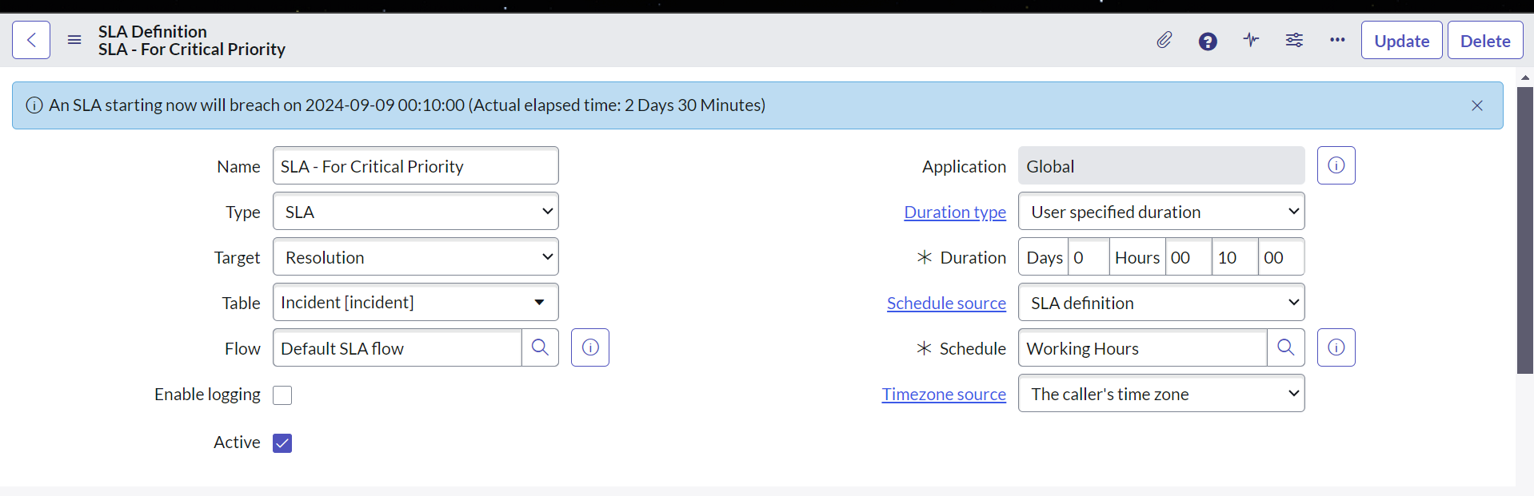

1. Add the required conditions like what will be the **Start conditions** of SLA, What will be the **Pause Condition** of SLA, what will be the **Stop conditions** of SLA and what will be the **Reset conditions** of SLA

**Start conditions:**

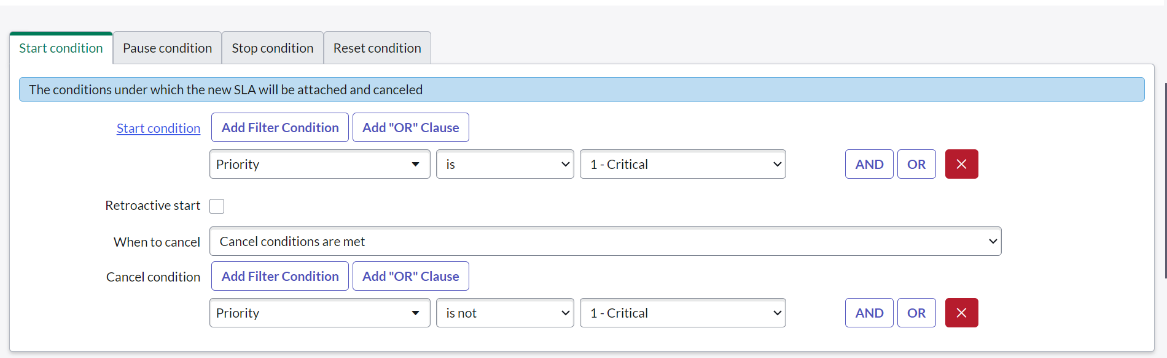

**Pause Condition:**

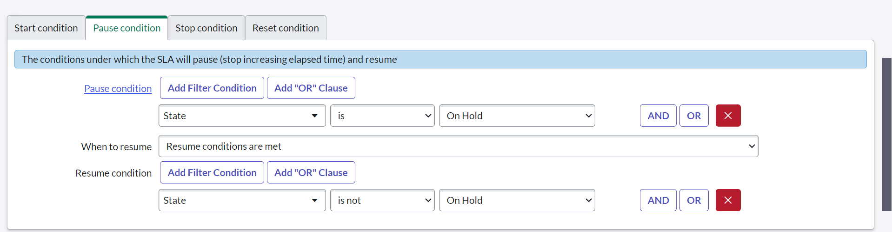

**Stop conditions:**

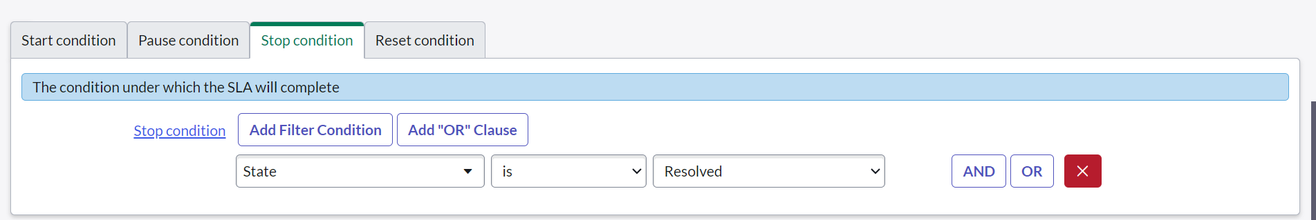

**Reset conditions:**

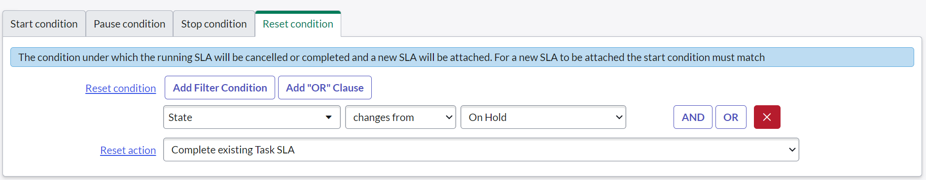

1. Save the form and your SLA should trigger on the start conditions defined

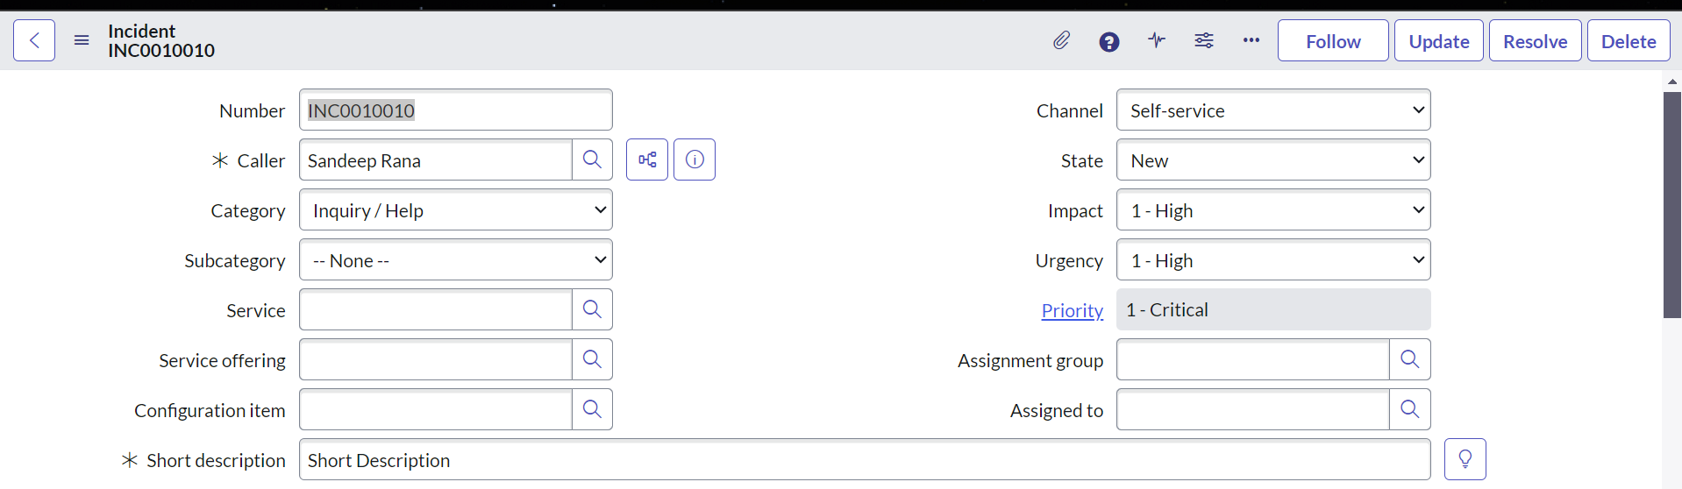

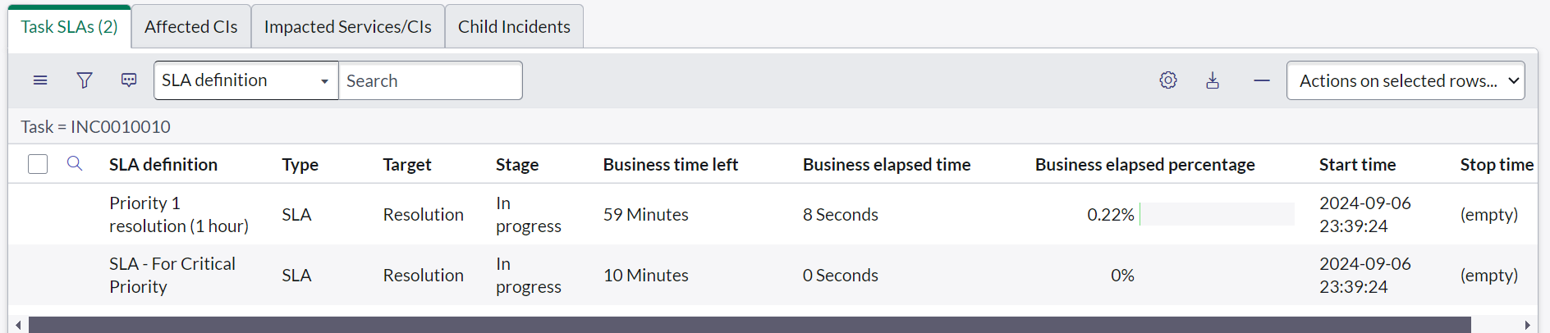

1. **Explain Response SLA?**

The **Response SLA** is when the target field is selected as **Response**.It is designed to ensure that a support team acknowledges or acts on an incident or request within a specified time.

Think of a Response SLA as a timer that helps ensure that support teams quickly acknowledge or start working on a problem. Here’s a simple way to understand it:

What a Response SLA Does:

1. Start of the Timer:

   - Imagine you have an incident, like a reported problem with the email system.

   - When this incident is created and meets certain conditions (e.g., its state is "New" and its description is "The entire corporate email system is down"), the Response SLA timer starts.

2. During the Timer:

   - The timer keeps running, and the goal is to see if the support team acknowledges the incident within a set amount of time, like 15 minutes.

3. Stopping the Timer:

   - The timer will stop or pause when the support team takes the first action to address the incident. This could be:

     - Changing the state of the incident to "In Progress."

     - Adding a note saying they are working on it.

4. Breaching:

   - If the support team doesn’t acknowledge or start working on the incident within the 15-minute window, the SLA will breach. This means the service standard was not met.

1. **Explain Resolution SLA**

A Resolution SLA is similar to a Response SLA, but instead of focusing on how quickly a support team acknowledges an issue, it focuses on how quickly the issue is fully resolved. Here’s a simple breakdown:

**The Resolution SLA timer starts** when the incident or request meets certain conditions. For example, it could start when the incident’s state changes to "In Progress" or when it’s first logged.

**The timer counts down** to track how long it takes to completely resolve the issue.

**The timer stops** when the issue is resolved. This means that the support team has completed all necessary actions and the incident is marked as "Resolved" or "Closed."

If the issue is not resolved within the set time frame (e.g., 1 hour), **the SLA will breach**. This means the service standard was not met for resolving the issue.

1. **Difference between Resolution and Response SLA**

The difference between Resolution and Response SLA are as follows:

|  |  |  |
| --- | --- | --- |
| Aspect | Response SLA | Resolution SLA |
| Purpose | Ensures that the support team acknowledges or starts working on the issue within a specified time. | Ensures that the issue is fully resolved within a specified time. |
| Timer Start | Starts when the incident/request meets certain conditions (e.g., state is "New"). | Starts when the incident/request meets certain conditions (e.g., state changes to "In Progress"). |
| Timer Stops | Stops or pauses when the first meaningful action is taken (e.g., state changes to "In Progress" or a work note is added). | Stops when the issue is resolved (e.g., incident is marked as "Resolved" or "Closed"). |
| Primary Focus | The speed of acknowledging or starting work on the incident. | The speed of resolving the incident or fulfilling the request. |
| Common Use Case | Critical for ensuring timely acknowledgment of urgent issues. | Critical for ensuring timely resolution of issues and service requests. |
| Typical Actions Tracked | Adding a work note, changing the state to "In Progress." | Completing all required tasks and changing the state to "Resolved" or "Closed." |
| Breaching | Occurs if the acknowledgment or action is not taken within the specified time. | Occurs if the issue is not fully resolved within the specified time. |
| Measurement Example | "Acknowledge an incident within 15 minutes of being logged." | "Resolve an incident within 2 hours of it being logged." |

1. **Difference between Business time left and Business elapsed time in SLA**

|  |  |  |
| --- | --- | --- |
| Metric | **Business Time Left** | Business Elapsed Time |
| Definition | Time remaining before SLA breach. | Time that has passed since SLA started. |
| Purpose | To determine how much time is left to meet the SLA target. | To track the amount of time used toward meeting the SLA target. |
| Usage | Helps in planning and ensuring timely action. | Helps in tracking progress and remaining time. |
| Calculation | Total SLA duration - Elapsed Business Time. | Time elapsed from SLA start to current time. |

1. **Retroactive start in SLA**

**Retroactive Start** in an SLA allows the timer to start from an earlier time, like when the task (e.g., an incident) was created, rather than when the SLA was applied. This helps capture all the time that has passed since the task was first logged, ensuring more accurate tracking.

**Simple Example:**

* **Task created**: 10 AM
* **SLA applied**: 12 PM
* **With Retroactive Start**: SLA timer starts from 10 AM, not 12 PM, counting the time from when the task was created.

1. **Difference between Retroactive start and Reset condition in SLA**

**Retroactive Start:**

* Purpose: Starts the SLA timer from a past time (e.g., when the task was created) instead of when the SLA was applied.
* Use Case: To account for time that has already passed before the SLA was attached.

**Reset Condition:**

* Purpose: Restarts the SLA timer if certain conditions are met (e.g., if an incident's state changes).
* Use Case: To restart the SLA when key changes occur in the task (e.g., reassignment or reopening).

1. **Data Policies**
2. **Transform Maps**
3. **Workflows and Flow Designer (Cognizant First Round)**
4. **Why to use Scripted Rest APIs? (Cognizant First Round)**

Scripted Rest APIs are used to create custom web services APIs endpoints that can be used by other system to fetch data from ServiceNow Instance.

Scripted Rest Apis follows REST structure and one can customize them to use different conventions.

One can define service endpoints, query parameters and headers for scripted Rest APIs

An example of Scripted Rest API to fetch HR Case for Incoming Email ID. The Active Flag is optional.



API Call:



Response From ServiceNow:



1. **MID Server**

in ServiceNow, A MID Server (Management, Instrumentation and Discovery Server) is a software that facilitates communication between the ServiceNow instance and external system or networks. It acts as a bridge for data flow, enabling ServiceNow to interact with systems behind firewalls or within private networks.

In short: A Mid Server in ServiceNow, is a tool that acts like a messenger between your company’s internal systems (like servers or databases) and your ServiceNow instance. It sits inside your network and safely sends data back and forth without exposing your internal system to the internet.

1. **Why to use Mid Server**

Mid server provides an additional layer of security. Following can be considered the reason to use Mid Server

1. **Discovery**: The MID Server is crucial for **Discovery** processes, where it collects data from devices, servers, and applications in your network and reports it back to ServiceNow.
2. **Integrations**: It enables **integration** with third-party systems by securely handling REST, SOAP, JDBC, and other types of connections that ServiceNow needs to interact with external services.
3. **Orchestration**: The MID Server allows ServiceNow to execute automation tasks, like running scripts or managing services directly on remote systems.
4. **Security**: It operates within your organization's network, ensuring data is transferred securely without exposing internal systems to the internet.

In summary, the MID Server is a key tool for securely extending ServiceNow’s capabilities beyond its cloud environment, enabling communication with systems and data that reside in local networks.

1. **Rest Messages (Cognizant First Round)**

REST messages are used to send HTTP requests to remote systems. This allows you to integrate ServiceNow with other applications or services by consuming their APIs. REST messages can be configured to use different HTTP methods like GET, POST, PUT, DELETE, etc., and can also handle authentication methods such as Basic Auth, OAuth, API keys, etc.

1. **Order Guide and Catalog Items**
2. **Domain Separation? (Fujitsu First Round)**
3. **Custom Applications (Fujitsu First Round)**
4. **What is current.update() and why should we avoid it?**
5. **What is Class.Create() method used for in Script include? (Cognizant First Round)**

In ServiceNow, **Class.create()** is a part of the ServiceNow JavaScript framework (**GlideScript**) and is primarily used to create custom classes and objects in Script Includes. It provides a mechanism for building reusable, structured code by defining classes, which are essential for organizing large scripts and functionalities in a modular way.

Let’s break this down in more detail:

**1. Where is Class.create() Defined?**

Class.create() is part of the **ServiceNow platform's core API**. It is not standard JavaScript but is specific to ServiceNow’s server-side scripting environment. This method is provided by ServiceNow's GlideScript framework, which extends JavaScript to support object-oriented programming on the platform.

This method helps define a class, mimicking object-oriented behavior found in other programming languages like Java or Python. The class created with Class.create() has an associated prototype, which allows you to define methods and properties that are shared across instances.

**2. Why is Class.create() Used?**

The purpose of Class.create() is to create structured, reusable code by encapsulating related logic and data within a "class." This is especially useful in Script Includes, where you want to write server-side code that is clean, maintainable, and can be easily instantiated or reused in other scripts.

Using classes provides several benefits:

* **Code Reusability**: You can define reusable methods and logic within a class, which can be instantiated and reused across different parts of the application.
* **Encapsulation**: You can bundle related functionality and data together, making the code more modular.
* **Maintainability**: Changes can be made to the class in a single place, and all instances will automatically reflect those changes.
* **OOP Structure**: By using Class.create(), you can structure your code in an object-oriented programming (OOP) way, which is beneficial when dealing with complex integrations, business logic, or reusable utility functions.

1. **What is initialize:function(){} Is used for in Script Include?**

The initialize function can be used to initialize global variables in the script include.  
These global variables will be accessible across the script include and any method or function can use these variables directly.



Calling and Output:



1. **What is Data Policy?**

Data policies are same as of UI policy in functionality. They also provide a mechanism to make a field mandatory or read only. However, where UI Policy works on the client side, data policies work on the server side.

Another difference is that the UI Policy can make field hidden while in Data Policy that feature is not present.

Data policies ensure that the value of a field is populated (if the field is mandatory) during any import or transform or any integration.

Let’s consider this scenario:  
There is a table Laptop Issues and the field Mobile Number is marked mandatory using Data Policy  
1) When you try to import an excel with some data and mobile number is not populated in that excel, then the upload will fail.





2) Now, lets assume that the data is being populated from Integration via flow designer and the mobile number is not populated there as well, then the flow will crash and the record will not be created.





1. **Integration between two ServiceNow instance HR Profile.**
2. **Difference between Opened for and Subject Person**

The subject person field refers to any user who is affected by any request or incident whereas the Opened For field refers to any user on whose behalf a case or request was created.

1. **Given a dynamic payload, fetch a particular email (sand@man.com) and get the user’s name and employee number from that email. (Cognizant First Round)**



1. **Add a related list on HR Case Table to all incidents that are created for that HR Case. (Fujitsu First Round)**
2. Navigate to System Definition -> Relationships
3. Create a new Record with name “Incident For Case Record”
4. Applies to Table will be HR Case
5. Queries from table will be Incident
6. Add a script to fetch incidents related to HR Case.



1. Navigate to any HR Case record and click on hamburger icon and select configure-> related list
2. Select the Relationship just created from the slush bucket and arrange accordingly on the related list tabs
3. Save the form and you will see the new related list on the case.



**(Cognizant Technical Round Questions [22 – 32])**

1. **In Transform Script, what is the difference between the OnAfter and**

**onComplete function difference**

1. **Create a flow that will send notification to assigned to when the case is not updated for last 5 days**

Follows these steps:

1. First Create a new Flow with Daily Trigger. Select Any time.



1. Modify a look up records action to get all the cases that were updated 5 days ago.



1. Check if such records exist



1. Add a loop to go send email for each case.



1. Set To, Subject and Body of the email



1. Remember, the receiving (To) will be assigned to of the case and the subject should contain the case number
2. **How can we add two values from source field into one field in target table. The target field is a string field.**

Given that the target field is a string field, one can concatenate the values from 2 field and merge into a single field. If required one can separate the two values with some symbol to be more precise.



1. **On an inbound integration, when will the business rule, on insert or on update**

It depends whether you are updating a record or inserting a new record using inbound integration. So, in an inbound integration, ServiceNow is accepting the third-party system data and manipulating its record. When manipulating the data, we will see the business rule will on the specified trigger.

1. **Given that we must write an onload and onchange script, can we write both these script in one place to avoid 2 scripts?**

Yes, we can write an onload script within and onchange script. This can reduce our effort and we do not have to write another new script for onload.

Here is how it will work:

1. Create a new client script
2. Select Table Name. (Total rewards table in this example)
3. Select a UI Type (All in this example)
4. Select Type as On Change Script
5. Select a field that’s modification will trigger the onchange script (State field in this example)



1. Write the below code.



1. Load an HR Case and see the first alert to run as the form loads.



1. Change the state field and see the onchange script running.



1. **GlideAggregate**
2. **Use GlideAggregate to create a HR Task if 5 HR Cases are created for a subject person. Assign the task to the subject person.**

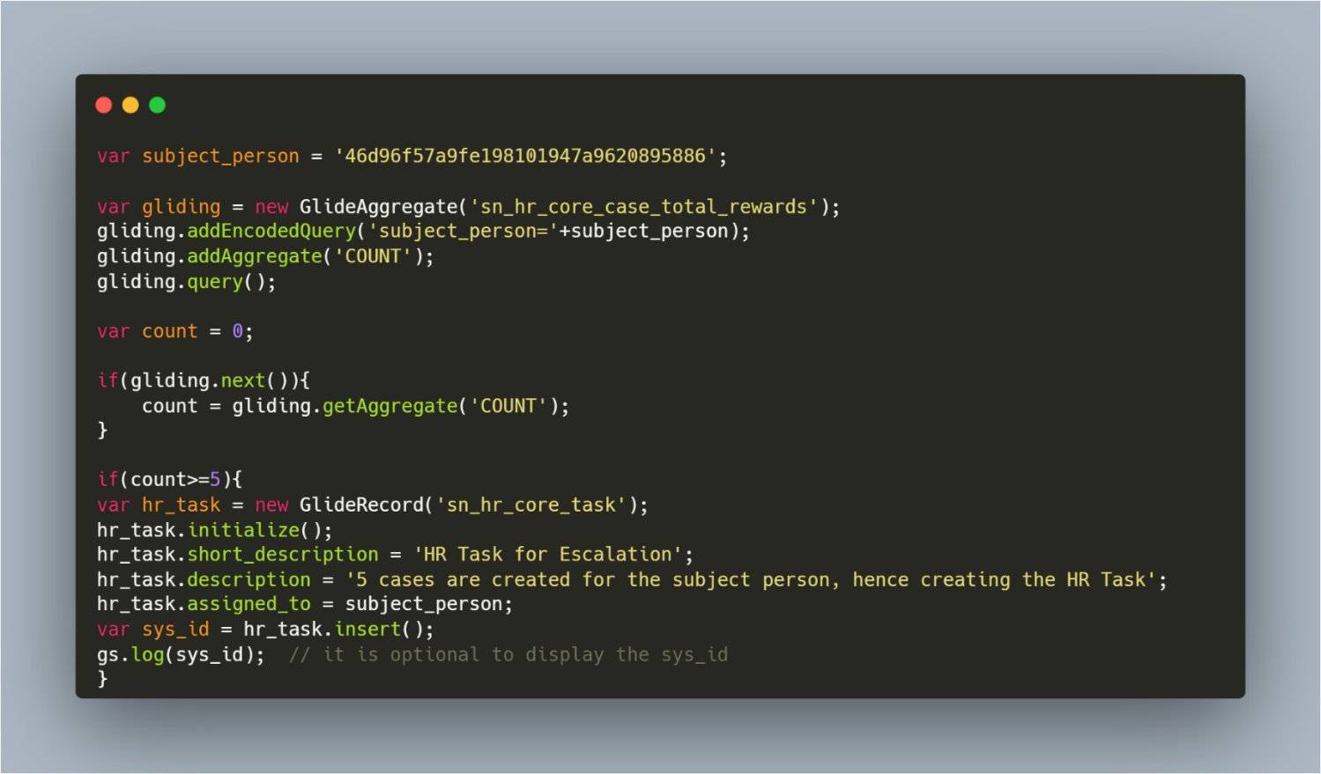



1. **Without GlideAggregrate, create a HR Task if 5 HR Cases are created for that subject person. Assign the task to the subject person.**





1. **Update a record without changing the updated date or updated by**

autoSysFields method available in the gliderecord object can help with the above scenario.



This will update the target record without updating the auto System fields like Created or Updated or Created by or Updated By

1. **In ServiceNow how can I check or track what data I have sent to third party?**

In ServiceNow, tracking and verifying the data sent to third parties requires a combination of configuration, monitoring, and auditing. Here's how you can check what data has been sent to third parties in ServiceNow:

1. **IntegrationHub and API Logs:**

- ServiceNow's IntegrationHub maintains logs of integration activities, including API requests and responses.

- You can review the IntegrationHub logs to see details of data payloads sent to third-party systems through integrations.

- Navigate to ` syslog_transaction_list.do` to view transaction logs, or check `System Logs` under `System Logs > All` for API-related activities.

2. **Data Export and Import Logs:**

- ServiceNow tracks data exports and imports through its data import/export logs.

- You can access these logs by navigating to `System Import Sets > Data Sources` or `System Import Sets > History`.

- Review the logs to identify any data exports or transfers to third-party systems.

3. **Audit Trails and Change History:**

- ServiceNow maintains an audit trail of data changes, which can help you track data sent to third parties.

- Navigate to individual records (e.g., incident records, task records, etc.) and check the `Audit` or `History` related links to view the change history.

- Look for changes indicating data sent to external systems or third parties.

4. **Scheduled Data Exports and Reports:**

- If you have scheduled data exports or reports that are sent to third parties, you can review these configurations.

- Navigate to `System Scheduler > Scheduled Jobs` to view scheduled data exports or reports.

- Review the configurations to identify what data is being exported and where it is being sent.

5. **Custom Applications and Workflows:**

- If you have custom applications or workflows that involve sending data to third parties, you can check these configurations.

- Review the workflows, business rules, and scripts associated with the custom applications to identify data transfers to third parties.

- Check any logging or auditing mechanisms implemented within the custom applications to track data sent to third parties.

6. **Third-Party Integration Documentation:**

- Refer to the documentation or configuration details of each third-party integration within ServiceNow.

- Review the integration settings, mappings, and transformations to understand what data is being sent to third parties.

- Ensure that data sharing agreements and compliance requirements are documented and accessible for reference.

By following these steps and leveraging ServiceNow's logging, auditing, and monitoring capabilities, you can check and verify what data has been sent to third parties. It's important to regularly review and monitor these activities to ensure compliance with regulations, data privacy policies, and security requirements.

1. **What is the use of the Message field on the client script?**

The message field is a multiline field in the client script and it is used to display messages on the form. You can use this field for Internationalization or to not hardcode messages within scripting (could be used for English language as well).

Within this field, you would mention the sys_ui_message record (the key). In the Client Script, you could reference that message by using getMessage()

1. Navigate to system UI -> Messages and create a new message



1. Create a client script
2. In the message field , add the key i.e display_message_in_client_script



1. Use the below script



1. Load the form and see the error message box displaying because we have used addErrorMessage Function.



**(Virtusa First Technical Round Questions [33 – 36]**

1. **Transform Scripts**

Transformation events occur during the process of transforming an import set table onto a target table. Transformation Event Scripts modify the transformation behaviour at different points in the transformation process. The *When* field choices are:

* **onStart**: executes at the start of an import before any rows are read
* **onAfter**: executes at the end of a row transformation and after the source row has been transformed into the target row and saved
* **onBefore**: executes at the start of a row transformation and before the row is transformed into the target row
* **onChoiceCreate**: executes at the start of a choice value creation before the new choice value is created
* **onComplete**: executes at the end of an import after all rows are read and transformed
* **onForeignInsert**: executes at the start of the creation of a related, referenced record before the record is created
* **onReject**: executes during foreign record or choice creation if the foreign record or choice is rejected; The entire transformation row is not saved

1. **Scheduled Data Imports**

Schedule imports to make it possible to specify that certain import operations occur at a regular interval.

To create a schedule data import:

1. Navigate to **System Import Sets -> Administration -> Scheduled Imports** from Application Navigator.
2. Click On New to create a new record
3. Provide it a Name , a data source to run , timing.



Optional) Provide Conditions or add pre or post script as per the requirement.

1. **Scheduled Data Exports**
2. **Server-Side UI Action**
3. **Use Client and Server Script both in One UI Action**
4. **Calling Script Include from Client Script**
5. **Call Rest Message in a Business Rule**
6. **Widget to Widget Communication**
7. **Custom Action**
8. **Script Include**

Script Includes are used to write Server Side Scripts which can be invoked later through any Business Rule , Schedule Job , Flow Designer.  
One can even create a client callable script include to fetch server data from Client Side using GlideAJAX

1. **GlideAJAX**

GlideAjax allows client scripts to fetch server side code from script includes.

To use GlideAJAX ,   
  
1) Create a client callable script include





This Script Include will fetch Current User’s Email and Name

2) Create a Client Script To Call this Script Include. You can create any type of Client Script i.e OnChange, OnLoad, OnSubmit. OnCellEdit.





3) So now, whenever you load a Total Rewards Case, an alert will popup with current logged in user’s email address.



1. **An example where you have used c.server.get() and c.server.update() in the same widget.**

**HTML :**



**CSS (optional) :**



**Client Script:**



**Server Script:**



1. **Report Visibility**
2. **ACL - Difference Between * and None**

Table.* is a field level ACL which gives Access to all field on that table.

Table.none is a row level or table level ACL which allows you to access records or access to the complete table.

Both are table level ACL, But the thing is * is a wild card entry. Suppose None is restricting table level access and you provide access by using *, system can allow you to do the work.

1. **Difference between $scope and $rootScope in widget**

$scope is used to communicate with embedded widget including both parent and child widget whereas $rootScope is used to communicate with widgets on same page.

**VIRTUSA SECOND ROUND**

1. **Javascript Libraries in ServiceNow Portal**
2. **UI Pages**

UI pages can be used to create and display forms, dialogs, lists, and other UI components. After creating a UI page , it can be called via a UI action or an Client Script and can be shown as a Dialog Window or a Modal on the page.

To create a dynamic UI page , the application should be in global, hence the UI page will also be in Global

**To Create a UI page:**

1. Navigate to System UI > UI Page
2. Add a title
3. Add the below code for HTML



1. Add the below code to Client Script



1. Client Callable Script Include for GlideAJAX



1. To Invoke the Code from a UI Action or Client Script and Show UI Page in ServiceNow Modal Window



1. To Invoke the Code from a UI Action or Client Script and Show UI Page in ServiceNow Dialog Window



There is a choice in step 6 and 7. The choice is yours as you can choose the Modal window or the Dialog Window.

Result:



1. **ACL on UI Pages**

You can create ACL on UI Pages similarly like you create ACL.

1. Elevate your role to Security Admin
2. Navigate to System Security -> Access Control (ACL)
3. Click on New To Create New ACL.
4. Select Type as UI page
5. Select other fields as per your choice
6. Save the form

You have successfully created an ACL on UI Page

1. **Virtual Agent for Agents**
2. **UI Scripts**

UI Scripts are reusable global client side Javascript code which we can call or run from other client-side scripts, such as Client Scripts, UI Pages. UI Macros, HTML Code etc.

In other words, UI Scripts are package which store client side Javascript that we can call from any other client scripts.

UI Scripts are not supported for mobile

You can create a UI script and designate it as global, which makes the script available on any form in the system. You cannot create a global UI script in a scoped application. You can mark a UI script as Global to make it available on any form in the system.

**To Create a Classless UI Script:**

1. Navigate to System UI > UI Scripts
2. Click on New to create new
3. Fill the following fields



1. Check Global only If you want the script to be globally available.
2. Write the Script



1. Call in From Any Client Script



**To Create A Classful UI Script:**

Replace the Step 5 with the following code



And Replace Step 6 with following Code



1. **UI Macros**

UI Macros are modular, reusable components that can be used throughout the ServiceNow platform.

UI Macros are discrete scripted components that administrator can add to the user interface.

UI Macros typically are the control which provides input and information which is not provided by existing field type. For ex: The action icon next to field, formatters etc.

To Create a UI Macro:

1. Navigate to System UI> UI Macros
2. Click On New to create a new UI Macro
3. Populate the following fields



1. Add the following Script and save the form



1. Now you can use this macro anywhere. Here I am using this on the caller field of the incident table.
2. Go to the caller field and configure dictionary and modify the attribute field



1. Save the form and you can see the macro created beside the caller field.



1. Click on it and a popup should show all the incidents created for this caller i.e Abel Tuter.



1. **Create a Javascript Library**
2. **Group has group manager. How can we edit or remove users as group manager?**
3. **Embedded List**
4. **GlideDate and GlideDateTime**
5. **Accept cookie banner on all pages**
6. **Calling Classless Script Include from Client Side**

Classless Script Includes, also called On-Demand Script Includes contains only one function and it cannot be called from the client side, even if the client callable checkbox is checked.  
However, you can call it from other script includes and make those script includes classful and call them from GlideAJAX if required.

1. **What is Classless Script Includes and why to use it?**

Classless script Includes, also called On-Demand Script Includes contains only functions.

Classless script includes can be used for several reasons:

1. **Simplicity and Flexibility**: Classless script includes provide a simpler and more straightforward way to encapsulate reusable logic without the overhead of defining classes. They are especially useful for smaller, straightforward pieces of logic where the complexity of classes may not be necessary.

2. **Procedural Programming**: If your development style leans more towards procedural programming rather than object-oriented programming, classless script includes offer a natural fit. They allow you to organize your code in a procedural manner without the need for classes and prototypes.

3. **Rapid Prototyping**: For quick prototyping or scripting tasks, classless script includes can be faster to write and easier to understand compared to setting up and managing classes.

4. **Legacy Code Compatibility**: In systems where a lot of legacy code exists without object-oriented patterns, classless script includes can seamlessly integrate with the existing codebase without introducing a new paradigm.

5. **Performance**: In some cases, classless script includes might offer slightly better performance compared to class-based script includes, as they don't involve the overhead of creating and managing class instances.

6. **Easier Migration**: If you're transitioning from procedural code to object-oriented code, starting with classless script includes might provide an easier transition path, allowing you to gradually refactor your codebase.

However, it's essential to note that the choice between classless and class-based script includes ultimately depends on the specific requirements of your application, your team's coding standards, and the complexity of the logic you're implementing. Both approaches have their advantages, and the decision should be based on what best fits your project's needs and your team's preferences.

1. **Variable Editor**
2. **GlideRecordSecure**
3. **Any alternative of GlideAJAX??**
4. **How to activate flow execution or flow reporting?**

To activate the flow reporting

1. Navigate to Process Automation -> Properties
2. Find the Property **Level of reporting data generated by the flow engine**
3. Select value for Flows and Actions

**This will enable the execution report for Flows and Actions**

1. **Write a code to print top 3 callers with the greatest number of incidents**





1. **If an ACL is restricting a user to view a field and an ACL is allowing a user to see a field, will the user be able to see the field or not**

If there is an ACL, that is allowing user to view the field, then no matter how many ACLs one creates on that field to restrict the view, user will still be able to see the field.

1. **Using an already existing HR Criteria in Record Producer**
2. When creating a HR Criteria, one can also create a User Criteria. It is automatically created and you can manually create a User Criteria out of an HR Criteria by clicking a Related link Create User Criteria



1. Navigate to your Record Producer-> Available for section and click on edit
2. Select the User Criteria created i.e **Laptop Fixers (HR Criteria)**

And that’s it.

1. **Using a Business Rule in Client Script**

Using g_scratchpad, one can use BR variables from client script, mostly Display Business Rule.

Refer to Question no. 9 for more details

1. **Without using ACL, restrict case creation for a HR Service for a particular group. Ex:  
   Payroll group should not be able to create Benefits HR Service and Benefits group should not see Payroll HR Service.**

COE to read/write payroll HR Cases

Similarly, create a COE security policy to allow only Benefits group to read/write benefits HR Cases

1. **In Which BR Can we use g_scratchpad?**

g_scratchpad can be used in display business rule to set variables that contains server-side data.

Refer to Question no. 9 for more details.

1. **Add subject person to CC in notification**

To set the CC in a notification, follow these steps

1. Navigate to Email Scripts and Create a new record



1. Provide a valid name and add the following code





1. Use it in a notification with ${mail_script:MAIL_SCRIPT_NAME} i.e **${mail_script:Add_CC_to_notification}** in this case
2. Fire the notification and check sys_email table copied field.



1. **Change the from field in Notification**

To change the from field default value in a notification, follow these steps:

1. Open or create a notification
2. Navigate to What it will contain section and click on **Advanced View** related link



1. The From and Reply To field will be visible
2. Add a valid email address there and save the notification



1. Trigger the notification
2. Navigate to sys_email and check the user field



1. **Show a Record Producer on Portal**
2. **Dictionary Override**

Let’s say there is a field that is created in a table and is extended to all child tables. The use case is that we need to make the field read only in child table, but making the field read-only will make it read-only across table.   
  
At this point, we can use dictionary overrides, to override dictionary for a particular table.

Example:

We can make assignment group field as read-only for incident table and it should remain non-read-only for other parent tables.  
We can configure the dictionary and add a new override for incident table.







1. **SOAP Integration**
2. **What is the difference between Topic Category and Topic Details**

Certainly! Here’s a clear distinction between "topic category" and "topic detail":

**Topic Category**

Definition:

- A broad, high-level classification that groups related topics within a specific domain or area of focus.

Purpose:

- To organize and structure the main areas of knowledge or activities.

- Helps in identifying major focus areas and facilitating resource allocation.

Example in HR:

- Talent Acquisition**

- Employee Development

- Compensation and Benefits

- Employee Relations

**Topic Detail**

Definition:

- Specific information, practices, guidelines, procedures, or case studies related to a particular topic within a category.

Purpose:

- To provide in-depth knowledge and actionable guidelines.

- Helps in addressing specific issues or tasks within the broader category.

Example in HR (under Talent Acquisition):

- Recruitment Planning: Developing recruitment strategies and defining job descriptions.

- Candidate Sourcing: Using job boards, social media, and employee referrals.

- Candidate Screening: Standardizing resume reviews, phone interviews, and skills assessments.

- Interview Techniques: Training on structured interviews and reducing bias.

- Onboarding: Creating comprehensive onboarding programs with orientation and mentorship.

**Summary**

- Topic Category: Broad classification (e.g., Talent Acquisition).

- Topic Detail: Specific components or practices within that classification (e.g., Recruitment Planning, Candidate Sourcing).

This structured approach ensures that major areas are well-organized (topic categories), while providing detailed guidance on specific tasks or issues (topic details).

1. **Hierarchy of COE in HRSD**

The Hierarchy of COE in HRSD is **COE -> Topic Category –> Topic Detail -> HR Service -> HR Cases**

1. COE – Coe is the Center of Excellence. COE can be described as the table which will represent a part of the HRSD functionality. Example -> **Payroll can be COE where all Payroll related cases like reimbursement, salary, hike, bonus will be present.**
2. Topic Category – Topic Category is a broad, high-level classification that groups related topics within a specific domain or area of focus. Example: **For Payroll COE, Payroll Administration** can be a topic category which will contain all the other Topic Details.  
   Topic Category also helps in maintaining the knowledge base.
3. Topic Detail – Topic Detail is the in-depth details of the topic. It provides specific information, practices, guidelines, procedures, or case studies related to a particular topic within a category. Example: For **Payroll COE**, topics can be reimbursement **Payroll Salary** or **Payroll Others**
4. HR Service – HR Service involves managing and supporting various functions related to human resources within an organization.

Example: **For Topic Detail - Payroll Salary**, service can be **Request advance Salary** or **Request Variable Pay**

**For Topic Detail - Payroll Others**, services can be **Request a reimbursement** or **request a salary hike**

1. **Difference between COE security and ACLs**

COE Security Configuration manages access to whole categories of HR cases, while ACLs control access to specific parts of those cases.

1. COE Security Configuration in HRSD:

- Purpose: Controls who can access different types of HR cases.

- Example: Decides which HR team members can see cases related to employee benefits or employee relations.

2. Access Control Lists (ACLs) in HRSD:

- Purpose: Controls access to specific details within HR records.

- Example: Sets permissions for who can view or edit fields in an HR case, like an employee's personal information.

1. **Show or Hide fields based on HR Service without using client script or UI policies**
2. **How do you know which release version of Service Now you are working on?**

Go to **System Diagnostics->Stats** and check the Build name.

Or navigate to **stats.do** and check the Build Name

1. **On Incident table, let us say, user selects priority as high (i.e Impact High and Urgency High). Write a BR to change the priority [impact and urgency] to Moderate whenever high priority is selected.**
2. Create a before business rule that will run on Incident table



1. Add the following script in the advanced tab



1. Save the form and it will work.
2. **Why do we need to impersonate a user in ServiceNow?**

Impersonation allows users with the admin role to temporarily become another authenticated user for testing purposes. When impersonating another user, the admin user can see and do exactly what the impersonated user can do. Impersonation does not require knowing the user's password.

1. **What is the difference between UI policy and data policy?**

UI Policy will work only on the form but not on List view. But if you create a data policy to make a field mandatory based on some value, it will also work in list view. UI policies are used to dynamically change the content of forms whereas data policies are used to enforce data consistency.

1. **How to use reporting in Service Portal**

- To Use a report in the Portal, first create a report from the native view

- Use the Report Widget and Pass the Report Name and you have the report in the portal



1. **How to encrypt payload during Integration**
2. **Mid Servers**
3. **How can I user Login without SSO or Password in Servicenow. Usecase: Let’s say there is a new employee whose’ account is not yet created, how will he/she login?**
4. **Deactivating a Service Portal**

Deactivating a Service Portal is not possible in ServiceNow. However, there are other measures one can take to avoid the portal

a) Redirect User to a different portal by adding a widget

b) Modify the portal url suffix to something else

c) Change the home page of the portal to a 404 page

Any of the above measure can be implemented to restrict the user from viewing it.

1. **UI Pages** **(Refer to Question 49)**
2. **Calling a UI Page from a widget**
3. **Journey Accelerator vs Lifecycle Events**
4. **Configure a COE**
5. **Managerial in HRSD**
6. **Call a rest message from UI Policy**
7. **What is a COE**
8. **COE Security Policy**

Center of Excellence (COE) Security Policy is used to define and enforce security controls for specific modules or areas within the platform. This is particularly useful for ensuring that sensitive information is protected and that only authorized users have access to certain data and functions.

1. **What all are the mandatory fields in COE Security Policy**

There are no mandatory fields in COE security policy. However, one can write a UI policy to make the fields mandatory

1. **Limit the access of a Service Portal**

To limit the access of a portal, you can follow the following steps:

a) Download the plugin **com.glide.service-portal.user-criteria** from Plugins

b) Once downloaded, Navigate to Service Portal -> Properties and enable the following property



Note: You must be in global scope for this activity

c) Now navigate to any portal page and load the related list, there you can see 2 items, Can view and cannot view

d) Can view - Is for users who all can view the portal

e) Cannot view – Is for the users who cannot view the portal

f) Create or use existing user criteria.

1. **ACLs in Client callable script includes**
2. **Drawbacks of using broadcast and emit function**

The main drawback of using the `broadcast` and `emit` functions in ServiceNow Service Portal is that they can create tight coupling between components. This means that if you have multiple widgets or components relying on these events, changes in one component can inadvertently affect others, making the system harder to maintain and debug. Additionally, if events are emitted too frequently or without careful management, it can lead to performance issues due to the overhead of handling numerous event listeners.

**EPAM – Round II**

1. **Consider a scenario, groups present in sys_group_table have a field called counter.**

**Task is to update the counter by 1, whenever an incident is resolved. Achieve this without using any GlideRecord or GlideAggregate or GlideRecordSecure or Flows.**

One can achieve this by using **getRefRecord()** function on a reference field of incident.

1. Create a Before Business Rule on Incident table and add filter to trigger when state changes to resolved
2. Use the following code and it is done.

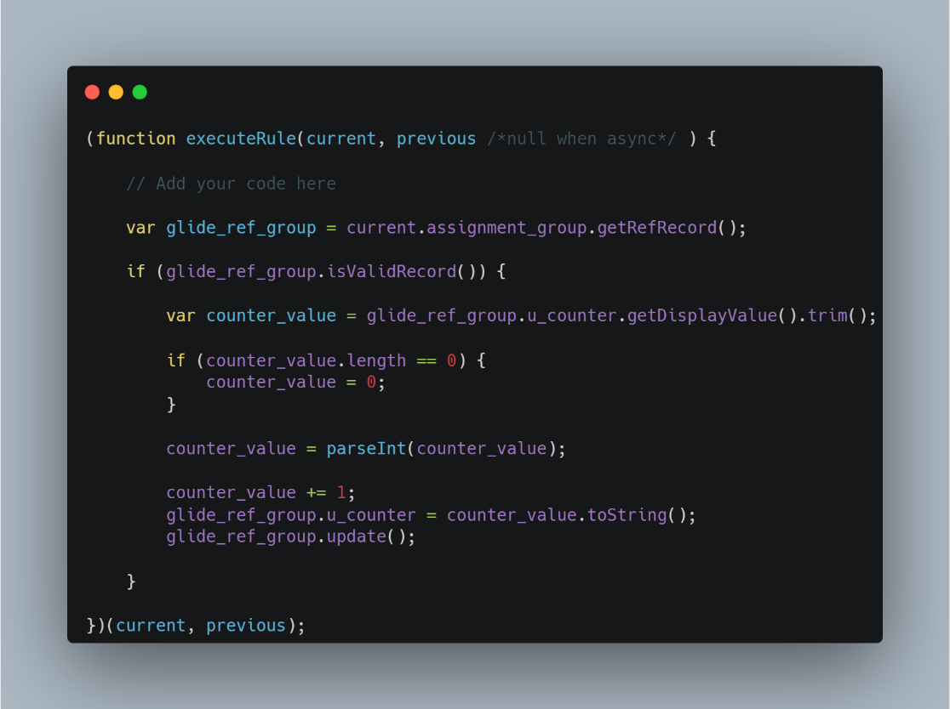

1. **Difference between UI policy and client script. Technical difference**
2. UI Policy cannot work on OnSubmit, whereas Client Script will work on OnSubmit
3. UI Policy cannot work on OnCellEdit, whereas Client Script will work on OnCellEdit
4. Client Script requires script to show or hide field whereas it is optional to write script in UI policy as we have UI Policy actions
5. Client Scripts have access to old values in onchange scripts but UI Policy donot have this feature
6. **Difference between glide record and gliderecordsecure**
7. **Send XML as payload as receive JSON as body**
8. **Define HTTP Headers**
9. **GSFTSubmit**
10. **Staging table during import**
11. **Sort without using javascript sort function**

**ServiceNow – Round I**

1. **Predict the output of below code**



It will execute the first console and then second console because, in third line we are doing assignment and assignments always returns true.

**105) Where can we check where our async BR is executing?**

Async business rule can be found in sys_trigger table i.e scheduled table.  
Filter on name with name contains Async and you can view all the async business rules triggering

Refer to [Performance considerations when using ASYNC Busine... - ServiceNow Community](https://www.servicenow.com/community/in-other-news/performance-considerations-when-using-async-business-rules/ba-p/2274036)

**106) Why not to use current.update in ServiceNow? Explain in detail**

Imagine you're working with a form in ServiceNow, and you write some code to automatically update certain fields when the form is saved. Now, when you save the form, your code runs and makes changes. But then, if you use `current.update()` in your code, it's like telling the form, "Hey, save again!" right after it was just saved.

**Why This Can Be a Problem:**

1. Infinite Loop:

   - If your code tells the form to save, and then it automatically tries to save again, this could keep happening over and over. The system might get stuck trying to save the form repeatedly, causing performance issues or even crashing the system.

2. Slower System:

   - Every time you tell the form to save again, it makes the system do extra work. This can slow things down, especially if you have a lot of records or if multiple people are working on the system at the same time.

3. Unexpected Changes:

   - When you save the form again, it might trigger other actions you didn’t intend, like sending emails, updating other records, or triggering other scripts. This can cause unexpected results and make it harder to understand what your code is doing.

**What You Can Do Instead:**

- Just Set the Fields:

  - Instead of telling the form to save again, just set the fields you want to change. ServiceNow will automatically save these changes when your code finishes running.

  - Example: `current.field_name = 'new value';`

- Use Separate Logic:

  - If you really need to update something else, you can create a new record object (a `GlideRecord`) and update that. This way, you control what gets saved and when.

By avoiding `current.update()` in your Business Rule, you keep things simple and prevent issues that could make the system behave unpredictably or slow down.

**106) How to configure SSO in ServiceNow?**

**Reference Video -> https://www.youtube.com/watch?v=mgLk5hMDGeo**

**To Configure SSO in ServiceNow, follow these steps:**

1. Install plugin : com.snc.integration.sso.multi.ui [Integration - Multiple Provider Single Sign-On Enhanced UI]
2. Once Installed, navigate to Multi-Provider SSO -> Identity Providers and Click New

**107) How to show a modal from a UI Action (UI action can use OOTB feature)?**

**108) Which widget to use to show virtual agent on custom portal?**

To add virtual agent to custom portal, follow the following steps:

1. Navigate to Service Portal -> Widgets
2. Find Widget with name = Virtual Agent Service Portal Widget and copy the widget id. [Note: Copy widget id, not the sys_id of the widget]. Example: sn-va-sp-widget
3. Navigate to Service Portal -> Portals and Open your custom portal
4. Open the theme of the portal
5. Open the footer present in the theme
6. Add the following code in the footer:

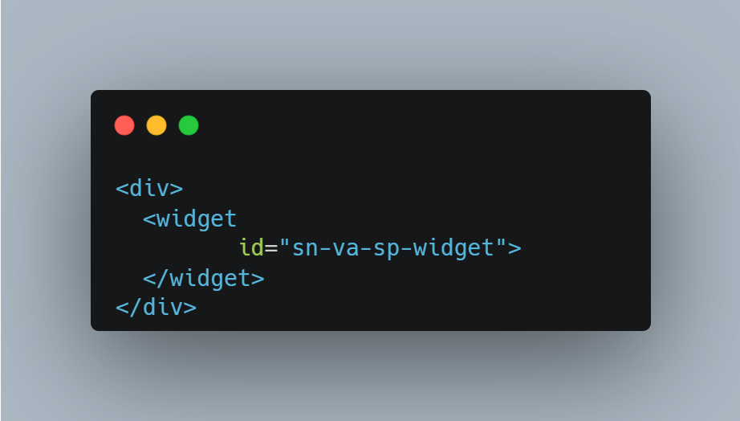

1. Save the footer record
2. Make sure that the Fixed Footer checkbox is checked in theme, else your virtual agent icon might float across the page.
3. Open your custom Portal and you will see the Virtual Agent

**109) Can lifecycle event be used for Request and RITM?**

**HRSD Interview Questions**

**Topic: Employee Journey Management**

1. **Difference between Human Resource: Lifecycle Event application and Human Resource: Lifecycle Enterprise application.**

The main difference is that Lifecycle Event application only allows task to remain inside the HR Scope whereas Lifecycle Enterprise allows task to be assigned to outside of HR scope.

1. **What are the roles installed with Lifecycle Event Plugin?**

When either LE plugin [events or enterprise] in activated, several LE specific roles are installed and each role begins with a prefix sn_hr_le. Name of those roles are as follows

1. sn_hr_le.admin – LE Admin reader and writer roles for Activity and LE Case.
2. HR Performance Analytics Admin
3. LE Activity Set Manager
4. LE Admin role is automatically added to HR admin [sn_hr_core.admin] role.
5. **What are all the necessary information a developer should collect when mapping a LE, before any configuration begins**

This includes a list of Activities, Assignment for each Activity, Task Template requirements, HR Service details and HR Template requirements.

1. **What is Activity Set**

Activity sets represent the different stages in a Lifecycle event [LE]. For example: in the New Hire Onboarding LE, preboarding, pre-hire and Day-1 are all activity sets. The task or activities, needed for LE are then grouped into appropriate activity set so they will be created at appropriate stage in the process.  
Trigger conditions, display order and audience may all be defined on each activity set.

1. **Define Trigger conditions, display order and audience**

**Trigger conditions:** Define when the activity set should be triggered/ initiated.

**Display Order:** Order number for when the activity set will be displayed in the LE builder and in the activity sets timeline on the Employee Center Page.

**Audience:** The specific employees of the activity set targets. Setting an audience for an activity set allows you to create activities within an activity set for a specific group of people. If the audience field is empty, the activity set applies to all employees.

Note: One can also defined audience at activity level but the Audience criteria for an activity set supersede or overrides the audience criteria for an activity.

1. **Define what all are the trigger conditions for an LE activity set**

The activity set trigger conditions field tells the system when an activity set should begin, and the business rules control the behaviour. Options are as follows:

1. **Immediate:** Activity sets triggers when a case is created
2. **Date:** Activity sets triggers before, on or after a specific date.
3. **Other Activity sets:** Activity sets triggers after one or more activity sets have completed. When an activity sets is triggered by other activity sets, it must wait for all dependencies to resolve before triggering.
4. **Advanced:** Activity set triggers according to the conditions defined in the trigger scripts
5. **Condition:** Activity set triggers according to conditions defined using the conditions builder.
6. **Combination:** Activity sets triggers using a combination of any of the other trigger conditions.
7. **What are activities in LE?**

Activities create case, request or task that are needed to fulfill a lifecycle event case. Activities are the task needed to complete the Lifecycle event. Each activity is associated with a single activity set.

Following are the activity types:

1. Approval
2. Employee Task
3. Fulfiller activity
4. Notification
5. Flow
6. Content
7. Activity Container
8. **What is audience in LE?**

The audience field allows lifecycle event activity or an entire activity set to be triggered only for those who met certain condition

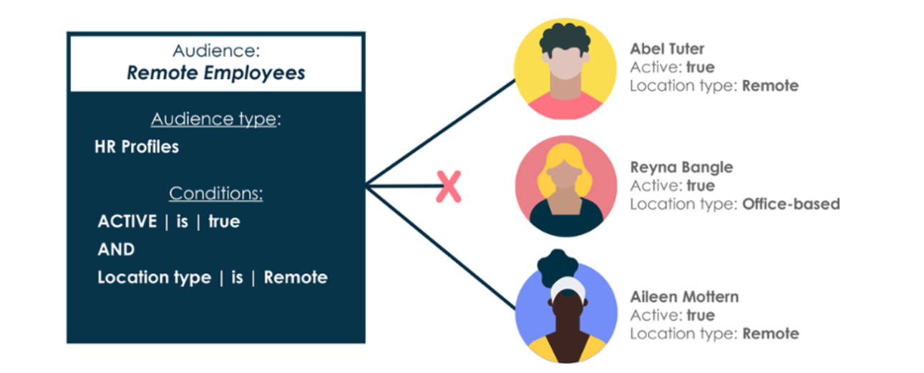

1. **Why is an audience used in LE?**

Audience records are used for several purposes:

1. Determine what an employee may view on the Employee Center.
2. Determine for which an employee to trigger a LE activity set.
3. Determine for which an employee to trigger an activity on a Lifecycle Event
4. Define when new hires are displayed on the org chart page and the My Team Widget in the Employee Center.
5. **What will happen if no Audience is selected in LE?**

If no audience is selected for any activity or activity set, each will trigger for each Lifecycle event time.

1. **What is Activity field mapping?**

It is used to pass information from LE case to child case or task. It is used to define the relationship between various fields in various tables.

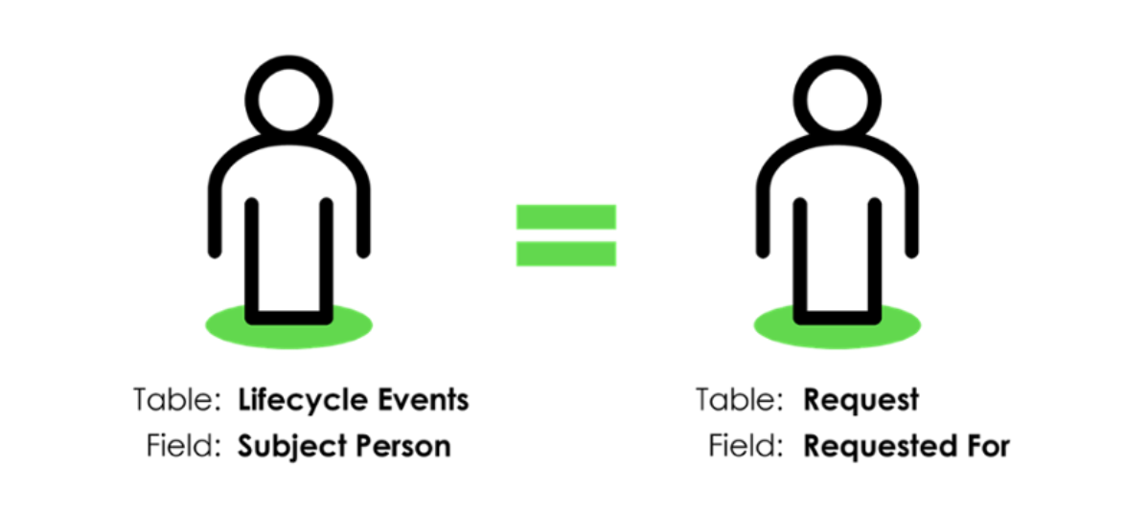

1. **What is Activity Container in LE?**

Activity Containers allow you to manage the dependencies of activities within an activity set. You can use activity containers to establish the order in which activities should occur.

It is used when certain activities within an activity set need to be triggered in order.

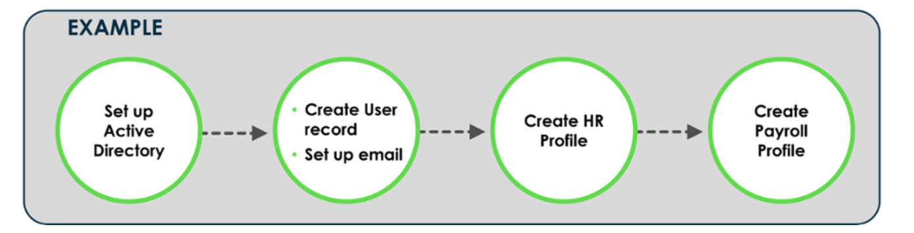

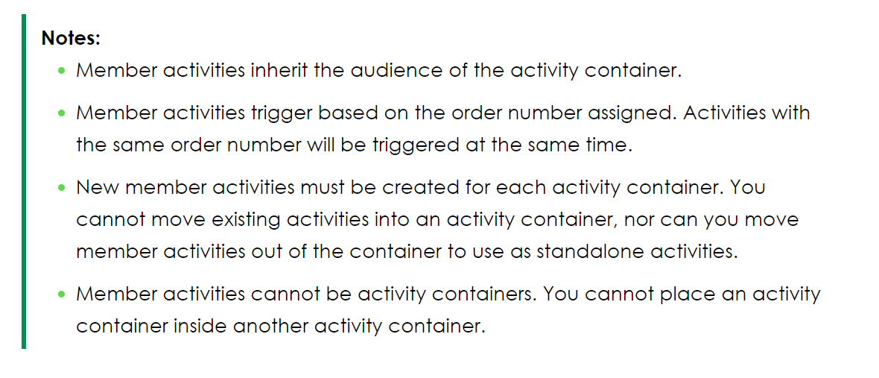

1. **How to test a Lifecycle Event?**

We can test a Lifecycle event by either creating a new case for that HR Service or by clicking Test On Activity Set.

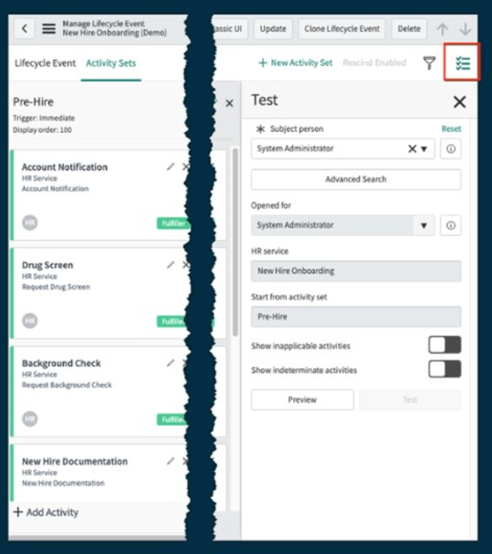

1. **What is Rescind Activity Set?**

Cancel and revert work done in a lifecycle event case with the Rescind process.

The Rescind activity set for LE allows admin to define the task that needs to be completed to backout any work that has been done in a Lifecycle Event.

Use Case: A new hire decides not to join the company

Rescind activities can be used to send notification when a case is rescinded, trigger automated flows and revert work already completed, such as return the equipment back to inventory like Laptop, headsets etc or workplace setup.

**Note:** As a leading practice, it is recommended that a Rescind Activity Set be configured for each Lifecycle Event.

**Note:** It is recommended that rescind activity sets should be configured for most of the Lifecycle Events

1. **What is Employee Request?**

Employee Request tasks are not triggered by a LE but rather created when an employee makes a request. Request can be either for a HR Service or a catalog Item and they can be associated with multiple activity sets.

When an employee request is submitted, the activity set completion Is depending on the fulfilment of the request. If a request is not made, the activity set can still reach a completed state

Use Case: A new hire decides to delay their start date

Note: Employee Request can be configured by the LE Admin [sn_hr_le.admin] or system admin.

1. **Lifecycle Event Dashboards**

Lifecycle event managers and fulfillers can track the progress of Lifecycle Event and Onboarding Cases using the lifecycle event dashboards.  
There is a dashboard showing results for lifecycle event cases and another specifically for onboarding cases. The onboarding dashboard is further divided by employee start date.

**Note**: If the customer has licensed Performance Analytics Premium and the Performance Analytics – Content Pack – Human Resource Lifecycle Events Scoped App [com.sn_hr_lifecycle_pa] plugin has been activated, they may also view the **Onboarding Executive Dashboard**

**Topic: Content Automation and Campaigns**

1. **How can HR Admins configure information displayed on the employee Center?**

HR Admins can configure information displayed on the Employee Center.

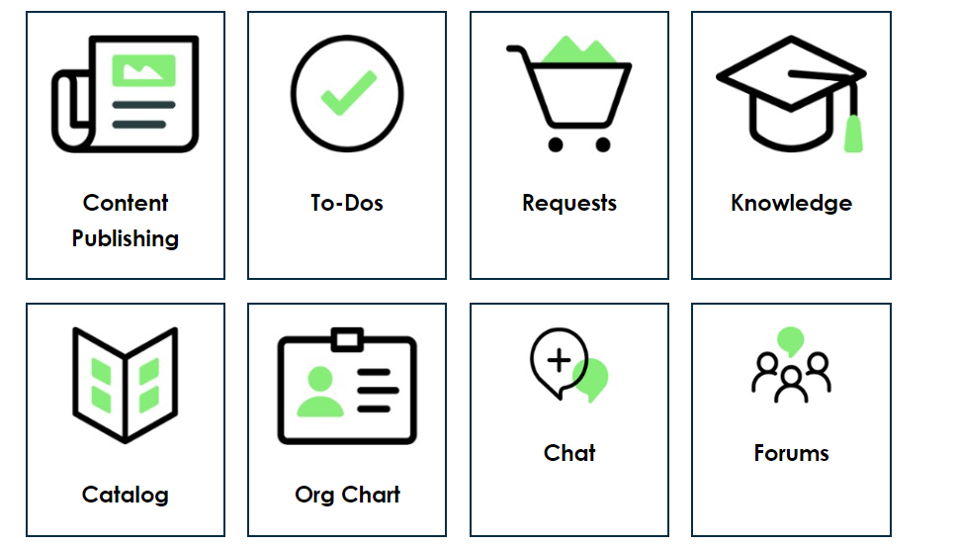

Content Publishing: Present employees with information such as videos, links to forum posts, links to news or articles, announcements, calendars and banners

To-Dos: Employee can view and complete all their assigned task. It can be configured to show approvals, content task, HR acceptance, HR task and more

Requests:

Knowledge:

Catalog

Org Chart

Chat

Forums

1. **What is Employee Document Management?**

The ServiceNow Employee Document Management (EDM) application provides storage space, a filing system and the ability to easily purge and retrieved documents.

EDM meets organizational and company documentation challenges by providing a centralized storage space. Controlling who can view the documents, automating when to purge documents and allowing documents to be put on legal hold. Essentially, **EDM creates an electronic version of physical filing cabinet for employee documents**

1. **What is the use of Bulk Import Feature Of EDM?**

It is common for an employee to have multiple documents associated with them throughout their tenure. The Bulk Import Feature streamline the uploading of those documents directly to HRSD as the goal is to not just upload a virtual file cabinet worth of data but also to maintain the integrity of the individual file folders within it.

1. **From how many sources can we configure Bulk Imports For EDM?**

We can configure the bulk imports from:

* Local file storage
* 3rd party cloud storage

**Topic: Secure HRSD**

1. **What are the 3 primary aspects to ServiceNow Security?**

The three main aspects of ServiceNow Security are:

* **Access to platform or Platform access:**
  + **User Authentication:** Local Login account with password, SSO or LDAP service to authenticate user credentials
  + **Instance Restriction:** IP Address Access Control
  + **Scoped Application:** Protects application by identifying and restricting access to the application files and data inherently.
* **Roles and Groups:** 
  + **Roles:** Allow users to access applications, modules, features, capabilities, forms and portals. Ex: admin, HR Admin, Delegated Developer etc.
  + **Groups:** These are used to grant the roles. Users are added to groups and each group member with inherit the group’s roles
* **Contextual Security:**
  + **Simple Security:** Protect data from field level using roles and controls the CRUD operations on data.
  + **Access Controls:** Uses context of the data within record to grant/restrict access, CRUD access of table, row and field level.

1. **What are Data Governance Methods?**

* Client Masking: Can prevent users from entering personal information in an HR Case. Create a new UI Macro to reference jQuery along with using the input mask plugin
* Exclude Tables: When cloning an instance. Exclude the HR Profile table so that it is not copied into non-production instances where HR may have less control over security and access.
* Prevent access to tables: ACLs can be written that limit access to tables. For example: if a Shared Service Center needs to access payroll table, other tables can be made inaccessible to them.
* Encryption: Encryption Plugin Required. Encryption is a process that scrambles information into a format that unauthorized parties can not view.